Digital Literacy Project Report
Name: Rushil Goyal
Course: CSE0001 Digital Literacy
University: VIT Bhopal University
Program: B.Tech Computer Science
Year: 1st Year

Introduction
Digital literacy is an important requirement for students to effectively participate in modern academic and professional environments. Through this project, I explored different digital platforms, practiced structured communication through formal emails, and gained awareness about online security risks. These activities helped me understand how technology can be used responsibly and productively.

Task-1: Infographic on Digital Literacy
Reflection
While preparing the infographic, I learned how digital literacy supports safe and meaningful use of online tools. I focused on essential student-level practices such as protecting personal information, identifying unsafe links, and maintaining professional email behavior. Designing the infographic improved my ability to present key information in a concise visual format and strengthened my understanding of responsible digital habits.

Task-2: Digital Portfolio Setup
Platforms created:
- GitHub Profile
- LinkedIn Profile
- HackerRank Profile
Reflection
Developing profiles on multiple platforms helped me create a structured digital presence as a beginner in computer science. Updating my academic details and skills improved my professional visibility. Practicing coding on HackerRank also supported my logical thinking and programming confidence. These platforms will be useful for showcasing my progress in future academic and internship opportunities.

Task-3: Platforms Activity
Activities completed:
- Completed a beginner-level coding challenge on HackerRank
- Designed an awareness quiz using Google Forms
- Observed and analyzed responses through Google Sheets
Reflection
This activity helped me understand how online platforms can be used for both technical learning and information collection. Creating the quiz improved my familiarity with digital survey tools, while solving the coding task strengthened my practical exposure to programming platforms used by students worldwide.

Task-4: Email Etiquette and Professional Communication
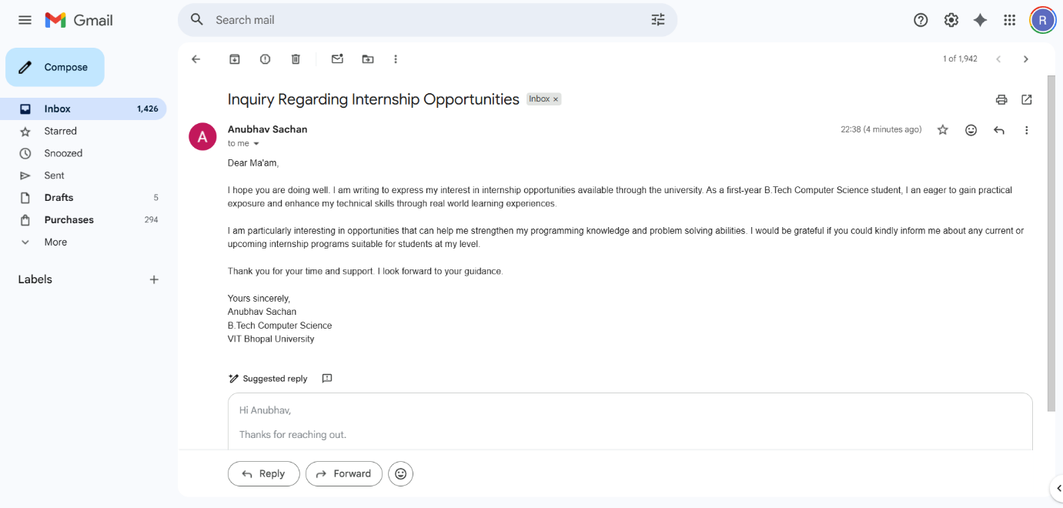
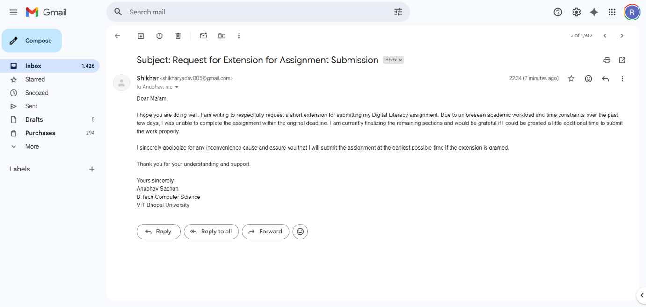
Reflection
This task helped me understand how formal emails should be written when communicating with faculty members and coordinators. I learned the importance of proper greetings, clear subject lines, and respectful language while maintaining a structured format throughout the email.

Task-5: Cybercrime Awareness Case Study
Case Study: UPI Payment Request Scam
With the increasing use of digital payment applications, UPI-related fraud cases are rising across India. One common type of fraud involves fake payment request approvals. In one such incident, a college student tried to sell a used electronic device online. The buyer contacted the student and claimed that he had sent the payment through UPI. Instead of transferring money, the fraudster actually sent a “collect request” and asked the student to approve it to receive the payment.
Believing the request was required to accept money, the student entered the UPI PIN and approved the request. Within seconds, money was deducted from the student’s bank account. The fraudster immediately stopped responding and blocked further communication. Later, the student realized that approving unknown collect requests can result in financial loss.
This case highlights the importance of understanding how UPI transactions work. Users should carefully check whether they are sending or receiving money before entering their UPI PIN. Awareness of such scams helps individuals avoid becoming victims and promotes safer use of digital payment systems.
Reflection
Studying cybercrime awareness increased my understanding of common online threats such as phishing and digital payment fraud. I also learned preventive steps that users can follow to stay secure and the importance of reporting cyber incidents through official channels.

Conclusion
Overall, this digital literacy project helped me improve my understanding of safe technology usage, professional communication methods, and the importance of maintaining a responsible digital presence. These skills will support my academic development and future technical learning journey.

